* **Activity1**

<?xmlversion="1.0"encoding="utf-8"?>

<businesscard>

<contactinfo>

<name>joe marini</name>

<home>+1 (415) 555-1234</home>

<work>+1 (800) 555-9687</work>

<mobile>+1 (510) 555-1212</mobile>

<email>joe@martini.com</email>

</contactinfo>

</businesscard>

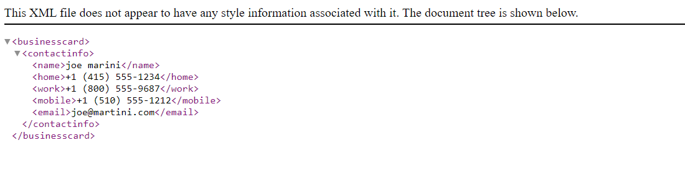

* **Activity2**

<?xmlversion="1.0"encoding="utf-8"standalone="yes"?>

<products>

<product>

<productName>Dog Shirt Gift Basket</productName>

<manufacturer> &#8482;SJB Pet Boutique</manufacturer>

<description>Something for every day of the week</description>

<pricecurrency="USD">&#36;35.99</price>

<pricecurrency="CAD">&#36;45.99</price>

<pricecurrency="EURO">&#8364;25.99</price>

<productItems>1200, 1201, 1202, 1203, 1204</productItems>

<message>

<![CDATA[

For further information, please visit <our website> or call us on #905-111-2222 & +1-800-111-2222

]]>

</message>

</product>

<product>

<productName>Cat Shirt Gift Basket</productName>

<manufacturer>&#8482;SJB Pet Boutique</manufacturer>

<description>Something for every day of the week</description>

<pricecurrency="USD">&#36;45.99</price>

<pricecurrency="CAD">&#36;75.99</price>

<pricecurrency="EURO">&#8364;35.99</price>

<productItems>1300, 1301, 1302, 1303, 1304</productItems>

</product>

</products>

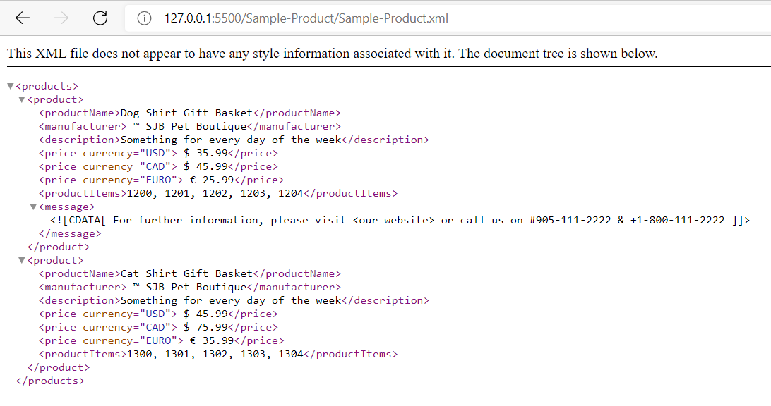

* **Activity3**

<?xmlversion="1.0"encoding="utf-8"standalone="yes"?>

<!-- DTD Declaration -->

<!DOCTYPE products[

<!ELEMENT products (product+) >

<!ELEMENT product (productName,manufacturer,description,price+,productItems) >

<!ELEMENT productName (#PCDATA) >

<!ELEMENT manufacturer (#PCDATA) >

<!ELEMENT description (#PCDATA) >

<!ELEMENT price (#PCDATA) >

<!ELEMENT productItems (#PCDATA) >

]>

<!-- DOCUMENT Body -->

<products>

<product>

<productName>Dog Shirt Gift Basket</productName>

<manufacturer>SJB Pet Boutique</manufacturer>

<description>Something for every day of the week</description>

<price>35.99</price>

<price>45.99</price>

<price>25.99</price>

<productItems>1200, 1201, 1202, 1203, 1204</productItems>

</product>

<product>

<productName>Cat Shirt Gift Basket</productName>

<manufacturer>SJB Pet Boutique</manufacturer>

<description>Something for every day of the week</description>

<price>45.99</price>

<price>75.99</price>

<price>35.99</price>

<productItems>1300, 1301, 1302, 1303, 1304</productItems>

</product>

</products>

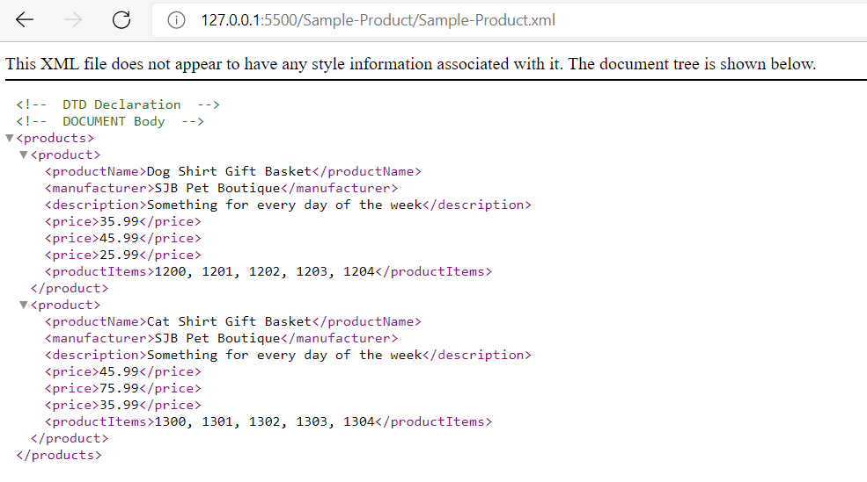

* **Activity4**

Q1. What is well-formed XML document?

1. An **XML document** with **correct** syntax is called "**Well Formed**" . Well formed XML is nothing but XML that has all tags closed in the proper order and, if it has a declaration, it has it as a first thing in the file with the proper attributes.

Q2. What is a valid XML document?

1. Valid XML documents are those which satisfies all that is mentioned in DTD. In other words a "valid" XML document must be well formed. In addition, it must conform to a document type definition.

Q3. Is Product.XML a well-formed XML document?

1. Yes, it is a well-formed document as it has all proper syntax as per XML.

Q4. Is Product.XML a VALID XML document?

1. Yes, it is a valid XML document as it satisfies all that is mentioned in DTD.

